Physiotherapist perceptions on rehabilitation services digitalization

Ciprian Vasile Pojala
PhD.
Transilvania University of Brașov
Email ciprianpojala@yahoo.com

Ionela Maria Bărsan
Assistant PhD
Transilvania University of Brașov
Email o.barsan@yahoo.com

Abstract
Digital health solutions have experienced an essential expansion during the COVID-19 pandemic. Digitization contributes to ensuring the continuity of care for people and offers the possibility of more accessible access to information related to the patient, facilitates communication and can be a way to provide medical services through telemedicine. This work aims to identify the potential of the digitization of physiotherapy services. 17 physiotherapists from Romania completed a questionnaire with ten items. The results showed that although physiotherapists consider themselves prepared for computer systems, their use in medical practice mainly relates to communication with colleagues and other medical specialties.

Keywords: information retrieval, healthcare, digital tools

1. Introduction
Once with the COVID-19 pandemic, in addition to the implications of health and epidemiological policies, among the health systems, many of the medical specialties that did not represent a medical emergency suffered both at the international and national levels (Davis , Bankhead-Kendall and Dumas, 2022).
Regarding rehabilitation, in most cases addressing cases of chronic disease, the legislation during the COVID-19 pandemic in Romania limited the access of chronic patients to physical rehabilitation services, implicitly to physiotherapy services. During the COVID-19 pandemic, services, applications and technologies were developed to favor telemedicine and telerehabilitation (Kim et el. 2022, Kreider et al. 2022). Moreover, to the extensive use of digital services and technologies generated by the COVID-19 pandemic, today's society is reshaping itself in a current and ongoing digital transformation as a central element and interfering with the health sector to a large extent. While some medical disciplines, such as radiology, have developed considerably concerning digital innovations, other medical specialties where a physical examination is required, such as orthopedics, rehabilitation and physiotherapy, are at an early stage of digital adaptation (Estel et al. 2022).
Besides telehealth, telemedicine and telerehabilitation, the digitalization of healthcare services also implies facilitating information gathering, retrieval and deposit. In healthcare services, the use of electronic patient files, the use of databases, specific software and technological tools is necessary for professional assistance. In physiotherapy, are available several digital tools, including smartphone applications which facilitate patient assessment (range of motion through smartphone camera), appointment schedule applications, or synchronized applications with wearable sensors (Rosettini et al. 2021, Ødegaard et al. 2021)
All these technologies, information retrieval and physiotherapy management require the professional significant knowledge and specific abilities or working preference to be translated to practice besides research purposes. Therefore, our research aims to identify the opinions of physiotherapists regarding physiotherapy services digitalization trough a pilot questionnaire.
Material and methods
After a literature consultation regarding the potential factors influencing physiotherapist perceptions regarding telerehabilitation and physiotherapy services digitalization, a questionnaire of ten items was developed. The questionnaire contained only ended questions, with 4 questions on a one to five scale and the other 6 questions with multiple answers. The questionnaire was disseminated through Google Forms, and 17 physiotherapists participated in the study. No personal data was required, and all participants approved consent for data.

2. Results
The sample size of the respondents was of 17 participants, with a mean age of 30.53 years , SD=7.49. The work experience average was 5.88 years with SD 4.24. From 17 participants, eight were females (47.05%) and nine males (52.95%); a percent of 41.18% (n=7) had a Bachelor degree, while 58.82% (n=10) were Master graduates. Thirteen participants (76.47%) came from urban area, while four (23.53%) from rural area.

Figure 1. Smartphone application use
The items used in the questionnaires are found within figures graphics and depicts percentage of physiotherapist perceptions regarding professional services digitization. One of the elements followed in the research was to identify the use and the perceptions of smartphone applications in physiotherapy practice.
In Figure 1 and Figure 2 the usability of electronic recordings, smartphone applications and other types of information access tools are depicted.

Figure 2. Information retrieval and dissemination
Most participants reported to use smartphone applications for communication with coworkers and more than half for organizing their professional service, while only 11.76% reported that use in daily practice an electronic file for patient’s data management. None of the participants perform video consultation or have a web-based page to offer information for patients. For the use of telemedicine, the item included actions like telephone communication with coworker, physicians or patients, and the item is not linked with video call services. Another usual tool used for information communication is the personal email.

Figure 3. Physiotherapy digitalization potential
As it regards the potential of physiotherapy services digitalization, the participants in the study agreed that it can facilitate information communication with colleagues and professional activity (Figure 3) and 50% percent considered that trough digitalization services, communication and patient’s care can be improved. If only the electronic patient file would be seriously implemented, the patient’s follow-up and further physiotherapy or rehabilitation clinic would require less time for gathering the necessary information and the patient would benefit of more therapy time.

Figure 4. Possible negative influences on physiotherapy services digitalization

As all new technologies or tools, awareness must be emphasized related to possible negative influences or outcomes of the appliance. In this aspect, in Figure 4 are depicted the physiotherapists opinions regarding the potential issues of professional services digitalization. Unfortunately, only 23.53% participants considered the patient’s data protection a potential issue, although is a tremendous problem in personal data and information protection, for the most of the healthcare providers. On the other side, the majority of the participants considered the finances as an important feature and reported this element as a high effort for physiotherapy digitalization. Another important element is linked to the practical implementation of digitalization technologies and software, suggesting that the physiotherapist have encountered issues in digital technology use in medical daily practice.
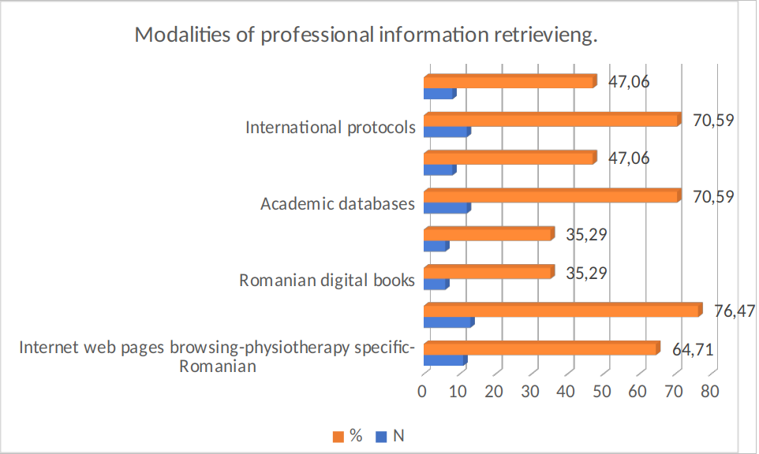
Figure 5. Physiotherapist’s modalities of professional information documentation

To create a better understanding of physiotherapists perceptions and acquittances regarding information retrieval, we used in our questionnaire an item to identify the methods by which they gather professional information. The results suggest that the academic databases and web pages navigation are the most preferred methods, while physical books reading is the lowest in physiotherapists preferences, the results suggesting that digital information is most accessible since personal internet computers and smartphones become accessible and user friendly.
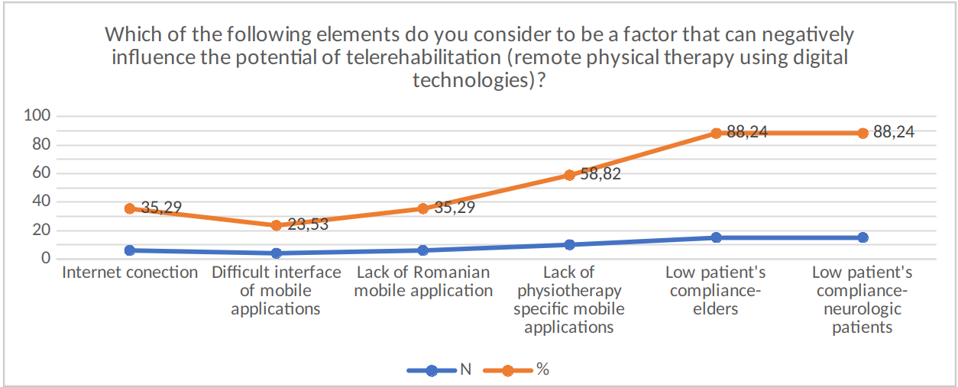
Figure 6. Potential factors of telerehabilitation limitations

As a future perspective of telerehabilitation, we asked the participants, based on their perceptions which of the following elements depicted in Figure 6 can negatively influence future physiotherapy digital practice; in high percent, the subjects considered that a significant impediment in telerehabilitation use might be elder or neurological patients, since they are not familiarized with the use of digital technology, nor as the neurological patients, who’s central nervous system is damaged and frequently, the cognition is affected.
Other important and limiting features are linked with small number of physiotherapy dedicated smartphone applications and the usability in Romanian language.
Other elements of the applied survey investigated the physiotherapists self-perception regarding the knowledge and the compliance with digital tools in daily practice. The results of the other 4 items are shown in Table 1.

Table 1. Physiotherapists self-perception on digital skills
On a scale from 1 to 5 | Mean±SD
How much "addapted" are you keeping yourself when it comes to digitizing your professional activities? | 3.76±0.64
To what extent do you consider that you have the skills to use mobile phone applications for organizing professional activities or for documenting the techniques and methods used in physical therapy. | 4.18±0.71
To what extent do you consider that you have the skills to search for documents in scientific databases? | 3.59±1.14
To what extent do you think that your interest in digital information/applications has increased after the pandemic? (in relation to professional activity) | 3.65±0.76

3. Discussions
The results of our research show that although physiotherapists seem to be aware of the importance of medical care services digitalization and the facilities they offer, the use of these technologies for information retrieval, data storage and flexible and distance communication are poorly implemented in daily practice.
A very small percent of participants reported to use the patient electronic file, which can represent a facile method to quiqly identify personal information, recorded assessments and other important healthcare data.
Another essential issue which seems that is not sufficiently taken into consideration is linked to patient’s data protetction when using digital tools for physiotherapy services; therefore, only a quartaer of the participants reported concerns regarding this issue, although nowadays, with the software development and legislation requirements, patient’s data protection is mandatory (Wacksman 2021).
Compared to the classic way of following up and running a rehabilitation program, telerehabilitation brings multiple advantages to everyone involved in the process. Unfortunately, our respondents seem not to use even the mobile phone for online consultation. The patient can perform the recovery program in his own comfort space. It can also notify the existence of a troublesome symptomatology. The patient acquires a sense of confidence in order to reinsert into the social circuit. The physiotherapist monitors effectiveness and adherence to therapy remotely and optimizes the program to maintain increased adherence (Rogante et al. 2015).
In our research, the physiotherapists expressed their concern regarding the use of digital physiotherapy services in neurological and elderly populations. Elderly and neurologic patients are more vulnerable to rehabilitation services to support function, physical activity and quality of life. These categories often have limited access to rehabilitation. Transportation to the clinic and low income are just two examples that can lead to non-performance of rehabilitation procedures. Whatsoever, even telerehabilitation can be an useful tool for home physiotherapy, new technologies may be difficult to use especially by the neurologic patients, since many of them have limbs and ambulation deficiencies, but also have cognitive disfunctions. Therefore, future research and telerehabilitation devices should focus on the usability of these new technologies, considering users functional and cognitive limitations (Bezuidenhout et al. 2022).
The development of medical services digitalization and the use of these technologies can have an important potential to redefine the physiotherapy practice especially by the segment of smart wearables, by creating a platform that is positioned between the current generation of wrist-based tools (smart watches/fitness bracelets) and ultra-specialized systems in medical institutions. Future directions of real-time information retrieval may become a trend in the coming years, namely the concern of modern man to develop prophylactic programs and features for an increased state of health, but also for monitoring patients with different illnesses like diabetes, heart rhythm dysfunction, increased blood pressure or oxygen consumption (Peretti et al. 2017).

4. Conclusions
Although it seems that Romanian physiotherapists are aware of the need of medical practice services digitalization and report to have knowledge on different types of mobile applications or electronic information programs, the physiotherapy services digitalization is very little used in everyday practice. Further research is needed to identify forthcoming directions and technologies which can facilitate physiotherapy practice digitalization.

5. References
Davis B, Bankhead-Kendall BK, Dumas RP. A review of COVID-19's impact on modern medical systems from a health organization management perspective. Health Technol (Berl). 2022;12(4):815-824. doi: 10.1007/s12553-022-00660-z. Epub 2022 Mar 25. PMID: 35371904; PMCID: PMC8956330.

Estel K, Scherer J, Dahl H, Wolber E, Forsat ND, Back DA. Potential of digitalization within physiotherapy: a comparative survey. BMC Health Serv Res. 2022 Apr 13;22(1):496. doi: 10.1186/s12913-022-07931-5. PMID: 35418069; PMCID: PMC9007581.

Kim SY, Daley K, Pruski AD, AlFarra T, Azola A, Gonzalez Fernandez M, Keszler MS, Friedel S, Haaf H, Segall H, Lien P, Cypher J, Mazariegos J, Raghavan P. Implementation of a Framework for Telerehabilitation in Clinical Care Across the Continuum During COVID-19 and Beyond. Am J Phys Med Rehabil. 2022 Jan 1;101(1):53-60. doi: 10.1097/PHM.0000000000001904. PMID: 34915545; PMCID: PMC8667677.

Kreider CM, Hale-Gallardo J, Kramer JC, Mburu S, Slamka MR, Findley KE, Myers KJ, Romero S. Providers' Shift to Telerehabilitation at the U.S. Veterans Health Administration During COVID-19: Practical Applications. Front Public Health. 2022 Mar 4;10:831762. doi: 10.3389/fpubh.2022.831762. PMID: 35309184; PMCID: PMC8931404.

Lucian Bezuidenhout,1,2 Conran Joseph,3 Charlotte Thurston,1Anthea Rhoda,2 Coralie English,4 and David Moulaee Conradsson Telerehabilitation during the COVID-19 pandemic in Sweden: a survey of use and perceptions among physiotherapists treating people with neurological diseases or older adults

Ødegaard NB, Myrhaug HT, Dahl-Michelsen T, Røe Y. Digital learning designs in physiotherapy education: a systematic review and meta-analysis. BMC Med Educ. 2021 Jan 13;21(1):48. doi: 10.1186/s12909-020-02483-w. PMID: 33441140; PMCID: PMC7805166.
Peretti A, Amenta F, Tayebati SK, Nittari G, Mahdi SS. Telerehabilitation: Review of the State-of-the-Art and Areas of Application. JMIR Rehabil Assist Technol. 2017;4(2):e7. doi: 10.2196/rehab.7511.

Rogante M, Kairy D, Giacomozzi C, Grigioni M. A quality assessment of systematic reviews on telerehabilitation: what does the evidence tell us? Ann Ist Super Sanita. 2015;51(1):11–18.

Rossettini G, Turolla A, Gudjonsdottir B, Kapreli E, Salchinger B, Verheyden G, Palese A, Dell'Isola A, de Caro JX. Digital Entry-Level Education in Physiotherapy: aCommentary to Inform Post-COVID-19 Future Directions. Med Sci Educ. 2021 Nov 4;31(6):2071-2083. doi: 10.1007/s40670-021-01439-z. PMID: 34754600; PMCID: PMC8567978.

Wacksman, J. Digitalization of contact tracing: balancing data privacy with public health benefit. Ethics Inf Technol 23, 855–861 (2021). https://doi.org/10.1007/s10676-021-09601-2

