Figure 1: Copyright Top Authors

Figure 2: Top countries in the field of Copyright

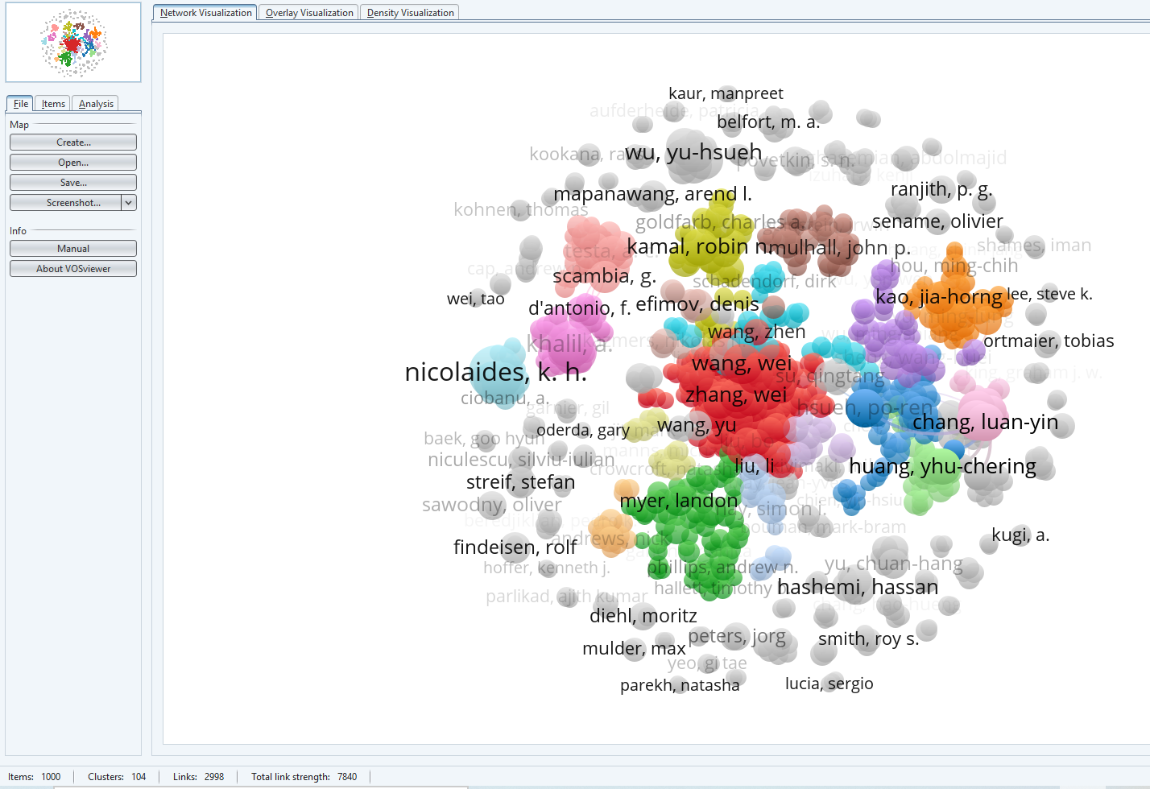
Figure 3: Collaboration between authors in the field of Copyright

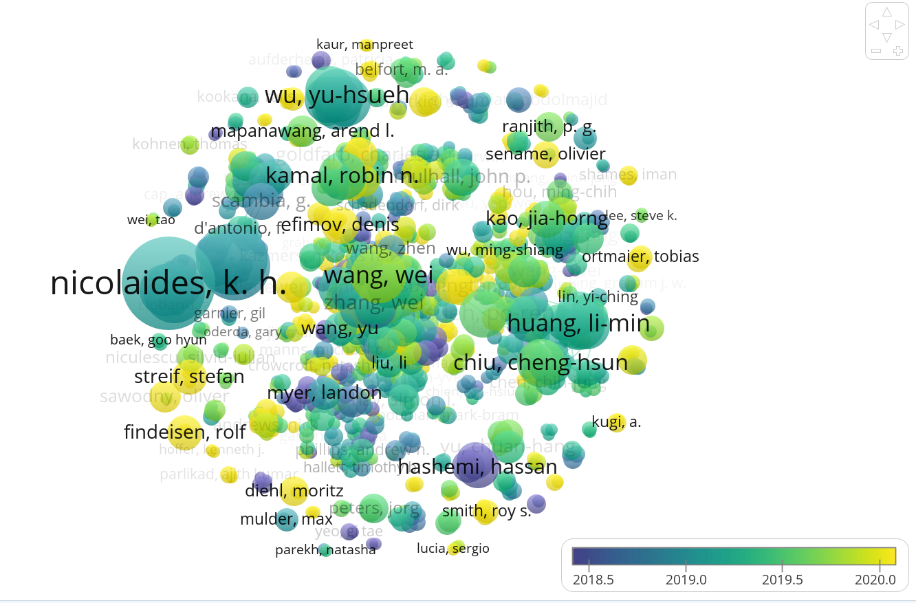
Figure 4: Superimposed static map — collaboration between authors and average publication period
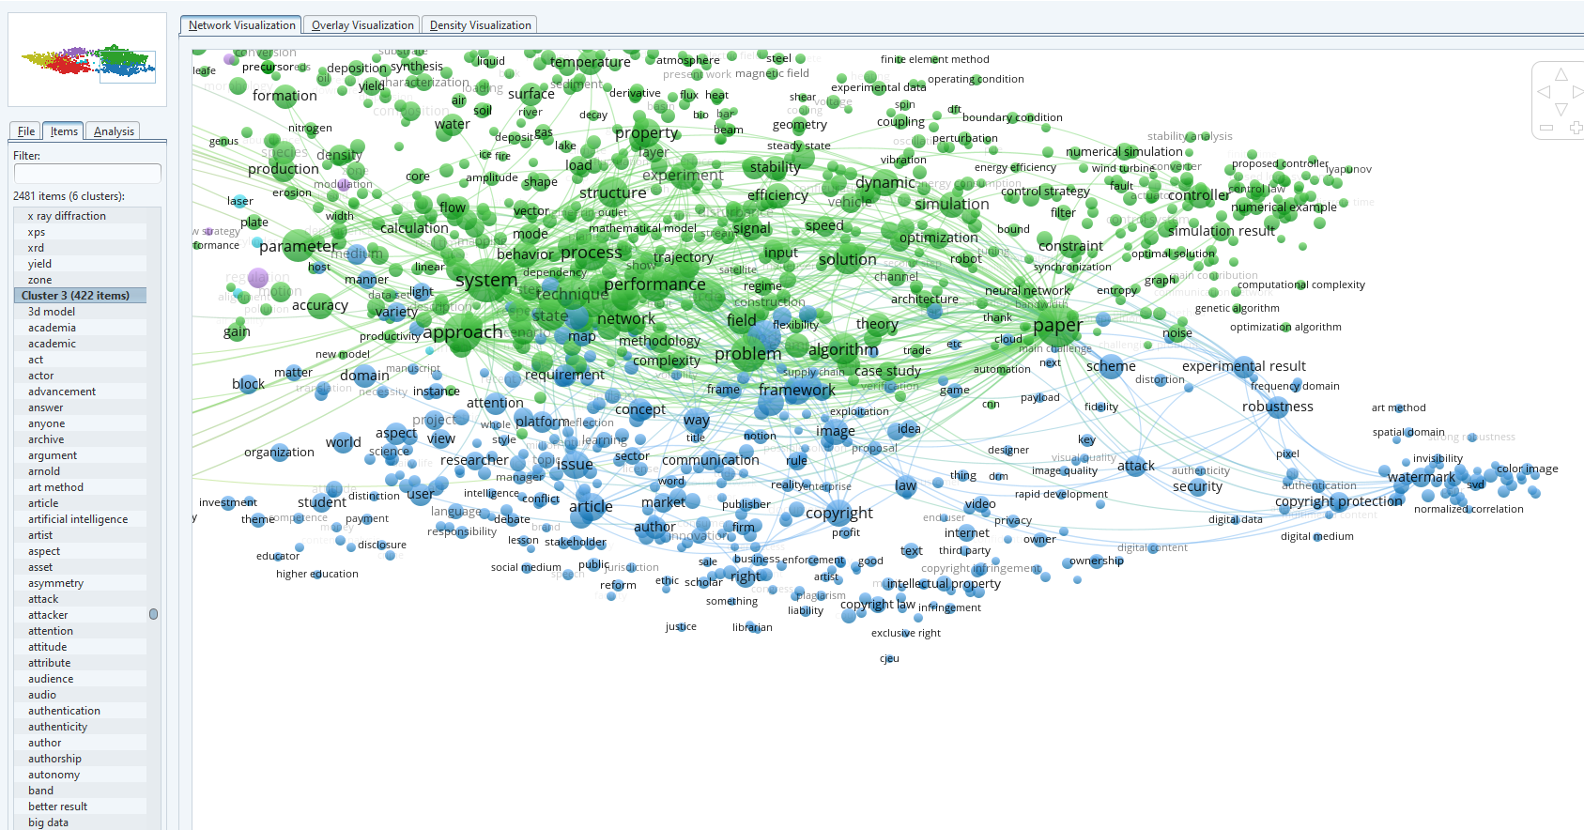
Figure 5. Overlapping view of semantic map

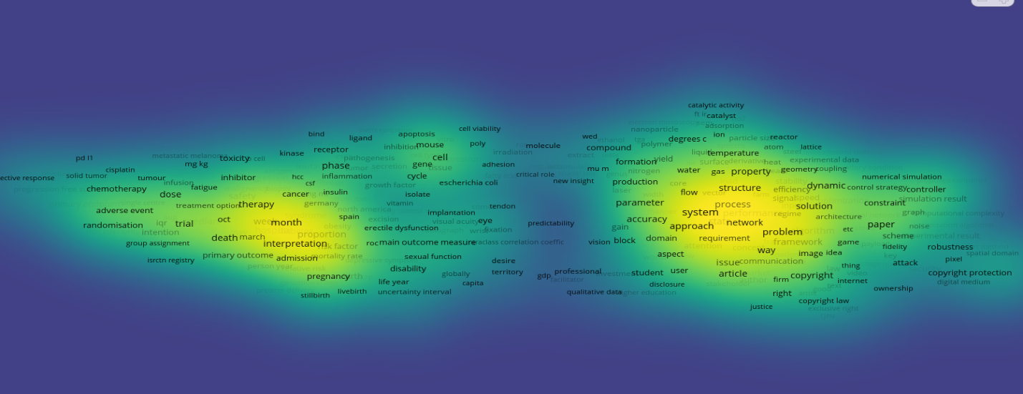
Figure 6. Semantic density visualisation map
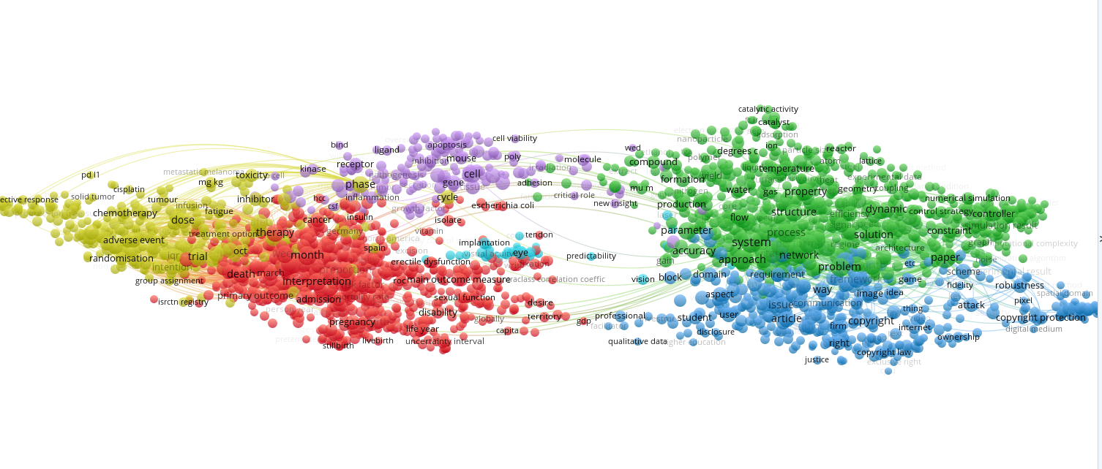
Figure 7. Semantic map view of keyword co-appearance
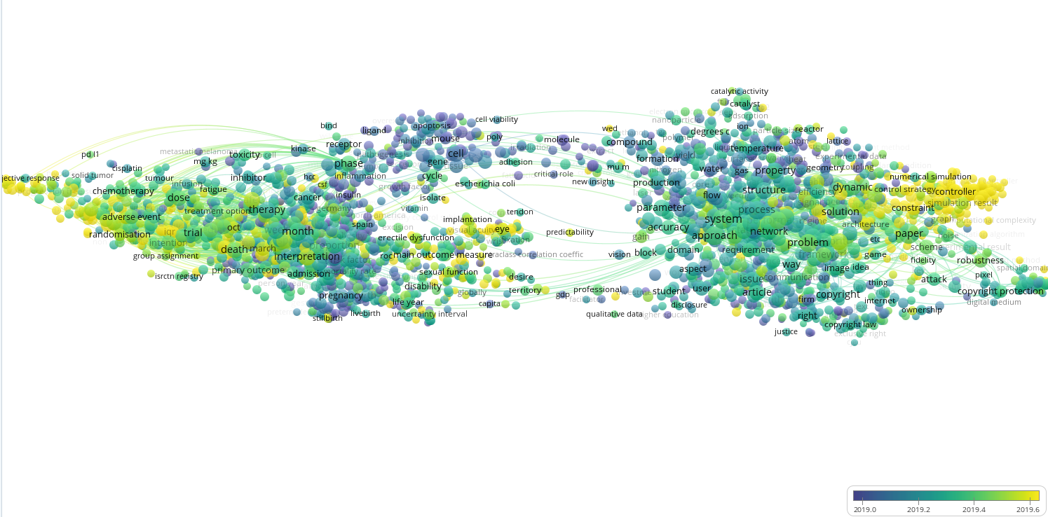
Figure 8. Semantic trend visualisation map according to the co-appearance of keywords

